Test Number | Test Case Type | Description | Test Steps | Test Data | Expected Results | Actual Results | Status  (Pass/Fail)
1 | Functionality | Application correctly allows the creation of a customer. | Navigating through the menu to sign up a new customer.  Inserting customer data as asked and then seeing it through until confirmation about the creation.  Viewing the program displaying confirmation with a messaging saying information added to the database. | Option “2” for main menu.  Option “1” for Creating new customer menu.  Inserting “John Smith” as full name and “AA123456B” as national insurance number.  Option “1” for photo identification, using “123456789” for the ID number.  Option “1” for Address menu, with reference number “123123”.  Option “1” for confirmation menu. | Application allows for traversal of different CLI menu interfaces, allowing customer data to be created and added, utility address being allowed to be used as an address type, with a reference number used, name and national insurance number also being used to create the customer profile and then displaying the customer being added to the database when all data is received. | Application allowed to smooth creation of customer, with expected fields being used and a confirmation at the end to inform users that the customer has been added to the database. | Pass
2 | Functionality | Application correctly allows for different type of address identification to be used for address prompt.
3 | Functionality | Account information is correctly stored when created.
4 | Functionality | Actions are correctly logged, to test this traversal of the application and several actions inputted before exiting and then view the logs text file to see proof of actions taken and logged.
5 | Usability | Menu traversal is smooth and easy to understand, so testing the ability to select options and then traverse back to the main menu.
6 | Usability | Application correctly allows exit of program.
7 | Usability | Prompted confirmation view when finalised step of customer creation has occurred.
8 | Database | Querying the database from the terminal to see if the program has saved customer data into the database
9 | Database | Querying the database from the terminal to see if the program has saved account data into the database

Testing Notes:
This section here is to provide description that gives clarity to any glaring issues that needs addressing, information not applicable for the table and useful advice needed.
Test Number 1
Step 1 | Sign up customer:
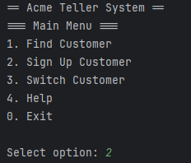
Step 2 | Continue signing up customer:
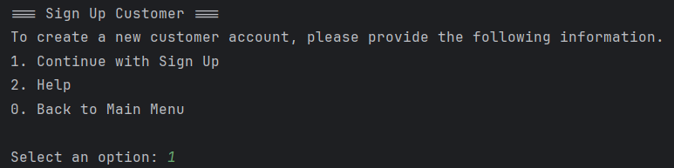
Step 3 | Inserting customer information:
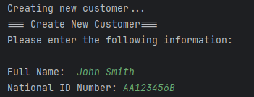
Step 4 | Inserting customer photo id number:
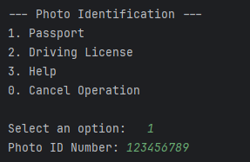
Step 5 | Selecting address type and inserting utility bill reference number:
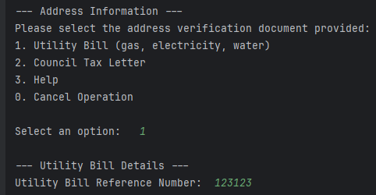
Step 6 | Confirming creation of customer:
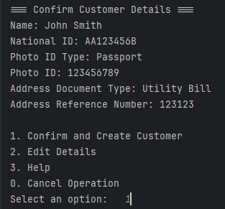
Step 7 | Viewing of customer added to database:
